

Mini Project Report

On
“STOCK MARKET PREDICTION USING MACHINE LEARNING”

Submitted in partial fulfillment of the

Requirements for the award of the degree of

Bachelor of Technology

In

Computer Science & Engineering-

Artificial Intelligence & Machine Learning

By

GAMPA HARISHWAR | – 21R21A6615
C ACHAL | – 21R21A6608
T PAVAN ADITYA | – 21R21A6657
GAVITI ANKESH | – 21R21A6618

Under the guidance of

Mrs. G SOWMYA

Associate Professor

Department of Computer Science & Engineering-

Artificial Intelligence & Machine Learning

2021 - 2025

Department of Computer Science & Engineering-Artificial Intelligence & Machine Learning

CERTIFICATE

This is to certify that the project entitled “Stock market prediction using Machine Learning” has been submitted by GAMPA HARISHWAR (21R21A6615), C ACHAL (21R21A6608),
T PAVAN ADITYA (21R21A6657) and GAVITI ANKESH (21R21A6618) in partial fulfillment of the requirements for the award of degree of Bachelor of Technology in Computer Science and Engineering from Jawaharlal Nehru Technological University, Hyderabad. The results embodied in this project have not been submitted to any other University or Institution for the award of any degree or diploma.

Internal Guide Project-Coordinator

External Examiner Head of the Department

Department of Computer Science & Engineering-Artificial Intelligence & Machine Learning

DECLARATION

We hereby declare that the project entitled “Stock Market Prediction using Machine Learning” is the work done during the period from August 2023 to January 2024 and is submitted in partial fulfillment of the requirements for the award of degree of Bachelor of Technology in Computer Science and Engineering- Artificial Intelligence & Machine Learning from Jawaharlal Nehru Technology University, Hyderabad. The results embodied in this project have not been submitted to any other university or Institution for the award of any degree or diploma.

GAMPA HARISHWAR | 21R21A6615
C ACHAL | 21R21A6608
T PAVAN ADITYA | 21R21A6657
GAVITI ANKESH | 21R21A6618

Department of Computer Science & Engineering-Artificial Intelligence & Machine Learning

ACKNOWLEDGEMENT

The satisfaction and euphoria that accompany the successful completion of any task would be incomplete without the mention of people who made it possible, whose constant guidance and encouragement crowned our efforts with success. It is a pleasant aspect that we now have the opportunity to express our guidance for all of them.
First of all, we would like to express our deep gratitude towards our internal guide

Mrs. G SOWMYA, Associate Professor, Department of CSE- Artificial Intelligence &

Machine Learning for her support in the completion of our dissertation. We wish to express our

sincere thanks to Mr.K.SaiPrasad, HOD, Department of CSE - Artificial Intelligence &

Machine Learning for providing the facilities to complete the dissertation.

We would like to thank all our faculty and friends for their help and constructive criticism during the project period. Finally, we are very much indebted to our parents for their moral support and encouragement to achieve goals.

GAMPA HARISHWAR | 21R21A6615
C ACHAL | 21R21A6608
T PAVAN ADITYA | 21R21A6657
GAVITI ANKESH | 21R21A6618

Department of Computer Science & Engineering-

Artificial Intelligence & Machine Learning

ABSTRACT

We all have heard the word stock one way or the other. Particularly stock is related with the organizations and companies which are commercialized and are settling in the world of marketization. Stock price prediction is an attempt to forecast the future value of an individual stock, a particular sector or the market, or the market as a whole. In Stock Price Prediction, the aim is to predict the future value of the financial stocks of a company. The recent trend in stock price prediction technologies is the use of Machine Learning which makes predictions based on the values of current stock market indices by training on their previous year values. Machine Learning(ML) itself employs different models to make prediction easier and authentic. The paper focuses on the use of LSTM (Long Short Term Memory) based Machine learning to predict stock values. LTSMs are a type of Recurrent Neural Network(RNN) for learning long term dependencies. It is commonly used for processing and predicting time-series data

LIST OF FIGURES & TABLES

Figure | Name of the Figure | Page
Number | Name of the Figure | Number
1 | Types of Machine Learning | 9
2 | Structure Chart | 11
3 | System Architecture | 12
4 | UML Diagram | 13
5 | Sequence Diagram | 14
6 | ML Model | 14
7 | Results | 28

Table Number |  | Name of the Table | Page
Table Number |  | Name of the Table | Number
1 | Results |  | 28

INDEX

CHAPTER 1
INTRODUCTION
1.1 OVERVIEW | 1
1.1.1 TIME SERIES ANALYSIS | 1
1.1.2 FUNDAMENTAL ANALYSIS | 1
1.2 PURPOSE OF THE PROJECT | 2
1.3 MOTIVATION | 2
CHAPTER 2
LITERATURE SURVEY | 3
2.1. SURVEY OF STOCK PREDICTION TECHNIQUES | 3

2.2. IMPACT OF FINANCIAL RATIOS & TECHNICAL ANALYSIS . 4

2.3. STOCK MARKET PREDICTION: USING HISTORICAL DATA ANALYSIS 4

CHAPTER 3

PROPOSED SYSTEM

3.1 PROPOSED SYSTEM
3.2 OBJECTIVES OF PROPOSED SYSTEM | 7

3.3 SYSTEM REQUIREMENTS | 8
3.3.1 SOFTWARE REQUIREMENTS | 8
3.3.2 HARDWARE REQUIREMENTS | 8
3.3.3 FUNCTIONAL REQUIREMENTS | 8
3.3.4 NON-FUNCTIONAL REQUIREMENTS | 9
3.4 CONCEPTS USED IN THE PROPOSED SYSTEM | 9
3.4.1 DATA PREPROCESSING | 9
3.4.2 MACHINE LEARNING AND ITS TYPES | 9
3.4.3 CLASSIFICATION | 9
3.5 WORKING OF LSTM MODEL | 10
3.5.1 CLASSIFICATION
CHAPTER 4
SYSTEM DESIGN | 11
4.1 STRUCTURE CHART | 11
4.2 PROPOSED SYSTEM ARCHITECTURE | 11
4.3 UML DIAGRAMS | 12
4.3.1 USE CASE DIAGRAM | 12
4.3.2 SEQUENCE DIAGRAM | 13
4.4 ML MODEL | 14
CHAPTER 5
IMPLEMENTATION | 15
5.1 DATA COLLECTION
5.2 TRAINING DATA
5.3 BUILDING MODEL

5.4 PREDICTING VALUES
CHAPTER 6 | 28
RESULTS
CHAPTER 7 | 29
CONCLUSION | 29
FUTURE ENHANCEMENT  REFERENCES | 29  30

CHAPTER 1

INTRODUCTION

1.1 OVERVIEW

Due to the high profit of the stock market, it is one of the most popular investments. People investigated for methods and tools that would increase their gains while minimizing the risk, as the level of trading and investing grew. Two stock exchanges namely- the National Stock Exchange (NSE) and the Bombay Stock Exchange (BSE), which are the most of the trading in Indian Stock Market takes place. Sensex and Nifty are the two prominent Indian Market Indexes. Since the prices in the stock market are dynamic, the stock market prediction is complicated.
From the very past years some forecasting models are developed for this kind of purpose and they have been applied to money market prediction. Generally, this classification is done by:
- Time series analysis

- Fundamental analysis

- Technical analysis

1.1.1 TIME SERIES ANALYSIS

The definition of forecasting can be like this: the valuation of some upcoming result or results by analyzing the past data. It extends to different areas like industry and business, economics and finance, environmental science. Forecasting problems can be classified as follows:
- Long term forecasting (estimation beyond 2 years)

- Medium-term forecasting (estimation for 1 to 2 years)

- Short term forecasting (estimation for weeks or months, days, minutes, few seconds)

1

1.1.2 FUNDAMENTAL ANALYSIS

Fundamental Analysts are concerned with the business that reasons the stock itself. They assess a company's historical performance as well as the reliability of its accounts. Different performance shares are created that aid the fundamental forecaster with calculating the validity of a stock, such as the P/E ratio. Warren Buffett is probably the foremost renowned of all Fundamental Analysts.

1.2 PURPOSE OF THE PROJECT

The purpose of project is to use machine learning to forecast stock prices, aiding investors in risk management, decision-making, and portfolio optimization. It supports algorithmic trading and contributes to financial research by analyzing historical data and market sentiment. However, predicting stock prices is challenging, and caution is advised in applying machine learning to financial markets, emphasizing continuous improvement and careful consideration of model limitations.
1.3 MOTIVATION

Businesses primarily run over customer’s satisfaction, customer reviews about their products. Shifts in sentiment on social media have been shown to correlate with shifts in stock markets. Identifying customer grievances thereby resolving them leads to customer satisfaction as well as trustworthiness of an organization. Hence there is a necessity of an unbiased automated system to classify customer reviews regarding any problem. Oftentimes, companies with the best intentions find themselves in an insights vacuum. The future price of a stock is the main motivation behind the stock price prediction. In various cases like business and industry, environmental science, finance and economics motivation can be useful. The future value of the company’s stock can be determined. Because
sentiment analysis can be automated, decisions can be made based on a significant amount of data rather than plain intuition.

2

CHAPTER 2

LITERATURE SURVEY

We conducted a thorough literature survey by reviewing existing systems for detecting fake and clone accounts. Research papers, journals and publications have also been referred in order to prepare this survey.

2.1. SURVEY OF STOCK PREDICTION TECHNIQUES
- The stock price prediction has become a progressively important issue in the present days. One of the methods used to do this is technical analysis, but such techniques do not always give accurate results.
- So, it is important to develop techniques for more accurate forecasting. Generally, funding’s are made using predictions that are obtained from the stock price after taking all the factors into the consideration that might affect it . The technique that was used in this situation was regression.
- Since financial stock markets generate huge amounts of data at any given time a great volume of data needs to go through analysis before a forecasting can be made. Every technique listed under regression has its own benefits and limitations over its other equivalents.
- One of the significant techniques that were introduced was linear regression. The way linear-regression model works is that they are often fitted using the least-squares approach, but they may on the other hand be also be fitted in some other ways, such as by decreasing the lack of fit in some other norm, or by decreasing a handicapped version of the least-squares loss-function. Similarly, the least- squares approach can be useful for fitting nonlinear models
3

2.2. IMPACT OF FINANCIAL RATIOS & TECHNICAL ANALYSIS
- The use of machine learning and artificial intelligence algorithms to forecast the values of the stock is an upwards trend.
- More and more investigators are spending their time every day finding best ways to arrive at techniques that can provide additional improvement in the perfection of the stock prediction model.
- Due to the wide number of options available, there can be many ways on how to predict the value of the stock, but all methods don't work in the same way.
- The output changes for every technique even if the same data set is being provided. In the quote paper the stock price forecasting has been carried out by using the LSTM which predicts future values by using financial ratios form the previous quarter or half year data.
- By using the financial-ratio of previous along with a model that can beneficially analyze values the perfection of the stock prediction model can be improved.

2.3. STOCK MARKET PREDICTION: USING HISTORICAL DATA ANALYSIS
- The stock price prediction process is filled with uncertainty and can be influenced by multiple factors.
- Therefore, the stock market plays an important role in business and finance. The technical and fundamental analysis is done by sentiment analysis process. Social media data has a greater effect due to its improved usage, and it can be helpful in forecasting the trend of the stock market.
- Technical analysis is done by applying the machine learning techniques on historical data of stock values.
4

- The process usually involves assembling different social media data, news to withdraw sentiments expressed by individuals. Other data like previous year stock values are also taken into consideration.
- The relationship between different data points is considered, and a forecasting is made on these data-points. The model was able to make predictions about future stock values.

2.4. A SURVEY ON STOCK MARKET PREDICTION USING MACHINE LEARNING

LSTM is a specialized category of RNN with a wide variety of applications, including text labeling, time series analysis, voice recognition, and speech-recognition.
LSTM has the capacity to recall values for future use from the earlier stages of a form of Recurrent Neural Network (RNN). LSTM units are designed to boost RNNs' ability to record previous values and assign priority in older data sequences to learning from newer ones. The earlier data trend can be memorized through some doors along with a memory line in the standard LSTM.
The memory of LSTM units also addresses the issue of disappearing gradients, as the memory allows a gradient to pass from one hidden layer to the next without being diminished. Each LSTM is a series of cells or device modules that collect and store data streams. The cells mimic the transport line in each cell (the upper line), which connects data from the past and gathers it for the current module from one module to the other.
LSTMs have been shown to be more potent than typical RNNs. Four neural network layers communicating with a particular approach are made of the LSTM layer. An ordinary LSTM device has three separate components, one cell, one escape door, and a forgotten door. The primary role of cells is to classify the values over random times and to monitor the data flow into and out of the cells.
Each LSTM requires three types of doors in order to control each cell's state:
Forget Gate produces a number between 0 and 1, where one demonstrates "to keep that completely," while 0 means "to disregard it completely." Memory Gate selects the latest data that must be processed in the cell. Next, a sigmoid layer, called " input layer," selects which values are altered. Then, a tanh layer generates a new candidate value vector that can be added to the state. - The Gate Output determines what output from each cell will be. The returned value and the filtered and newly inserted data are based on the cells. Both feed-forward and back-time dependencies are taught via bi-Directional Neural Networks.
5
Each unit is divided into two units with the same entrance and connected to the same output in a bi-directional LSTM. One unit is used for the sequence of time and the other for the sequence of time. The typical output performs an arithmetic process such as number, average, and concatenation of the two units. Bi-directional LSTM thus makes it useful to benefit from time-series data that span longer.
LSTM plays a significant role in stock market forecasting; it can derive valuable patterns from broad temporal records. The LSTM approach to stock market behavior is a relatively recent, active, and promising area. Although there have been reasonable findings for LSTM, many researchers are still attempting, by using a hybrid approach and considering more external variables, to improve the precision of the stock market forecast to achieve a more precise prediction. We learned that the stock market has so many external forces as non-linear, unpredictable, and subject to pressures. This article can be used as instructional material for those involved in forecasting stocks using LSTM.

6

CHAPTER 3

PROPOSED SYSTEM

3.1 PROPOSED SYSTEM

In this proposed system, we focus on predicting the stock values using machine learning algorithms like LSTM (Long Short Term Memory). We proposed a system called “Stock Price prediction”. We predicted the stock market price using LSTM. In this proposed system, we are able to train a machine from the various data points from the previous years to make a future prediction. We took the stock values from the previous year stocks to train the model. We used many machine-learning libraries to solve the problem. The first one was the NumPy package, which was used to clean and manipulate the data, and get it ready for analysis.

The datasets we used from the previous year stocks were collected from Yahoo Finance, 80 % of data was used to train the machine and the rest 20% for testing data. The basic procedure of the supervised-learning model is to learn the patterns and relationships in the data from the trained set of data and then replicate them for the test-data. We used the python pandas library for data processing which combined different data sets into a data frame. The tuned up data-frame allowed us to prepare the data for feature production. The data-frame features were date and the closing-price for a specified day. We also quantified the accuracy by using the predictions for the test set and the actual values.

3.2 OBJECTIVES OF PROPOSED SYSTEM

- To predict the stock market prices and visualize them in the most precise and accurate manner.

- To provide investors an estimated cost of stock market price so that they can invest in the share market.
- Through the predicted and analyzed data, companies and industry can use it to break down their limitations and enhance their stock value.

7

3.3 SYSTEM REQUIREMENTS

Here are the requirements for developing and deploying the application.

Operating System | : | Windows family
Technology | : | Python 3.6
IDE | : | Jupyter Notebook

3.3.1 SOFTWARE REQUIREMENTS

Below are the software requirements for the application development:

- The required language is python

- Editor for Python - Jypyter Notebook or Google Colab.

- ML Libraries for Model Building

- Google Chrome, Firefox, Microsoft Edge or Brave Browser with Extension Support

3.3.2 HARDWARE REQUIREMENTS

Below are the hardware requirements for the application development:

- Operating System: any

- Processor: intel i3(min)

- Ram: 4 GB(min)

- Hard Disk: 256GB(min)

3.3.3 FUNCTIONAL REQUIREMENTS

- The software shall accept the tw_spydata_raw.csv dataset as input.

- The software shall do pre-processing (like verifying for missing data values) on input for model training.
- The software shall use LSTM ARCHITECTURE as the main component of the software.

- It processes the given input data by producing the most possible outcomes of a CLOSING

STOCK PRICE.

8

3.3.4 NON-FUNCTIONAL REQUIREMENTS

● Reliability: Software must be able to handle the exceptions quickly and efficiently and must recover on time.

- Usability: It must be easy for users to make the decision to invest.

- Performance: It should be able to check the current stock market trends.

- Input: The offered data sets must be connected to realistic trends.

3.4 CONCEPTS USED IN THE PROPOSED SYSTEM

3.4.1 DATA PREPROCESSING

Preprocessing is a data mining technique used to turn the raw data into a format that is both practical and effective.

3.4.2 MACHINE LEARNING AND ITS TYPES

Machine learning (ML) is a branch of study devoted to comprehending and developing "learning" methods, i.e., methods that use data to enhance performance on a certain set of tasks.
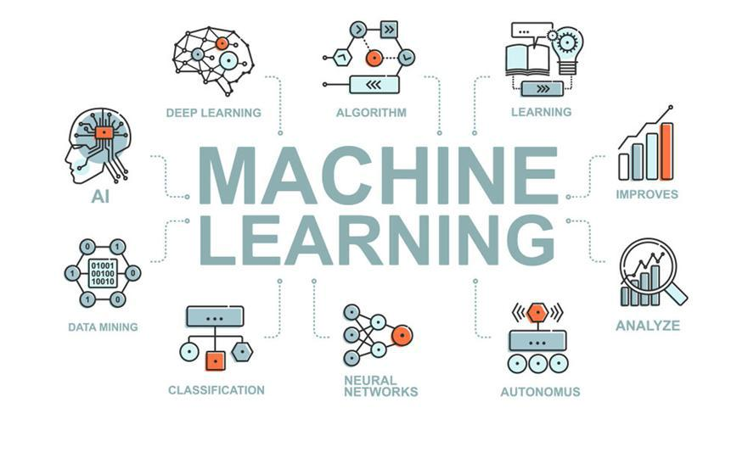

3.4.3 CLASSIFICATION

In machine learning and statistics, classification is a supervised learning technique in which the computer program makes new observations or classifications based on the data that is provided to it. It is a method of classifying a set of data into groups.

It may be used with both structured and unstructured data. Predicting the class of the provided

9

data points is the first step in the procedure. The terms target, label, and classes are frequently used to describe the classes.

3.5 WORKING OF LSTM MODEL

Long Short Term Memory is a kind of recurrent neural network. In RNN output from the last step is fed as input within the present step. It tackled the matter of long-term dependencies of RNN within which the RNN will not predict the word hold on within the long term memory however can offer additional accurate forecasts from the recent info. Because the gap length will increase RNN does not offer an economical performance. LSTM will by default retain the knowledge for a long period of time. It is used for processing, predicting and classifying on the basis of time-series data.

3.5.1 CLASSIFICATION

- LSTM has a chain organization that contains four neural networks and different memory blocks called cells.
- LSTM has a new structure called a memory cell. The memory cell makes the decisions about what information to store, and when to allow reading, writing and forgetting.
A memory cell contains three main gates:

o Input gate- a new value flows into the memory cell.

o Forget gate- a value remains in the memory cell.

o Output gate- value in the memory cell is used to compute the output.

10

CHAPTER 4

SYSTEM DESIGN

4.1 STRUCTURE CHART

A structure chart (SC) in software engineering and organizational theory is a chart which shows the breakdown of a system to its lowest manageable levels. They are used in structured programming to arrange program modules into a tree. Each module is represented by a box, which contains the module's name.
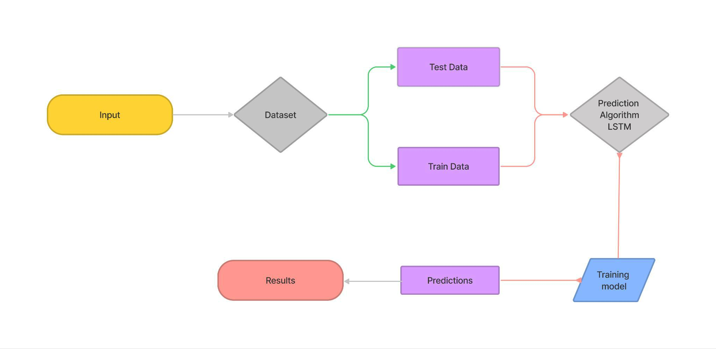

4.2 PROPOSED SYSTEM ARCHITECTURE

An architectural diagram outlines the system’s components, their relationships, and system functionality. A huge dataset where the data is pre-processed, then it is classified using SVM algorithm and finally the model is trained. Users input the account data into the application, which
evaluates the account based on its attributes and determines whether the account is fake or original.

The final output is then sent to the user.

11

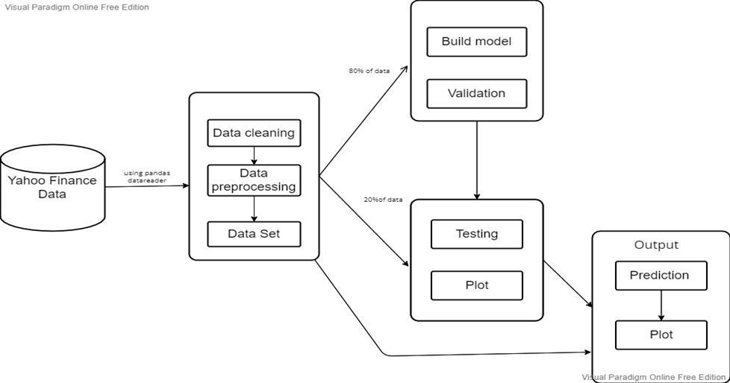

4.3 UML DIAGRAMS

4.3.1 USE CASE DIAGRAM

The use case diagram describes the function and scope of the system and also the system requirements. In the Unified Modelling Language (UML), a use case diagram can summarize the details of your system's users (also known as actors) and their interactions with the system. To build one, you'll use a set of specialized symbols and connectors. An effective use case diagram can help your team discuss and represent:
- Scenarios in which your system or application interacts with people, organizations, or external systems.
- Goals that your system or application helps those entities (known as actors) achieve.

- The scope of your system

12

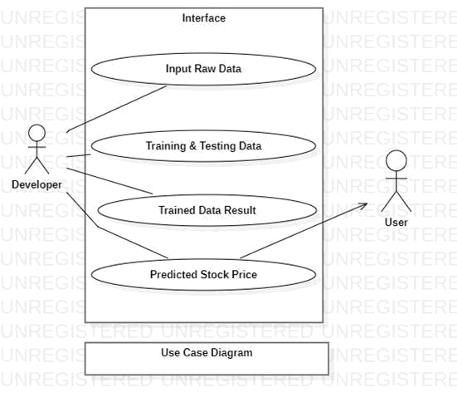

4.3.2 SEQUENCE DIAGRAM

A sequence diagram is a type of interaction diagram because it describes how and in what order a group of objects works together. These diagrams are used by software developers and business professionals to understand requirements for a new system or to document an existing process. Sequence diagrams are sometimes known as event diagrams or event scenarios.

Sequence diagrams can be useful references for businesses and other organizations. Try drawing a sequence diagram to:

- Represent the details of a UML use case.

- Model the logic of a sophisticated procedure, function, or operation.

- See how objects and components interact with each other to complete a process.

- Plan and understand the detailed functionality of an existing or future scenario.

13

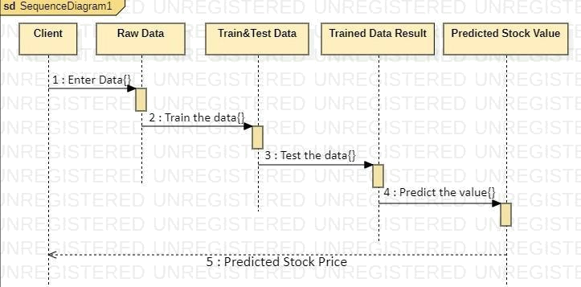

4.4 ML MODEL

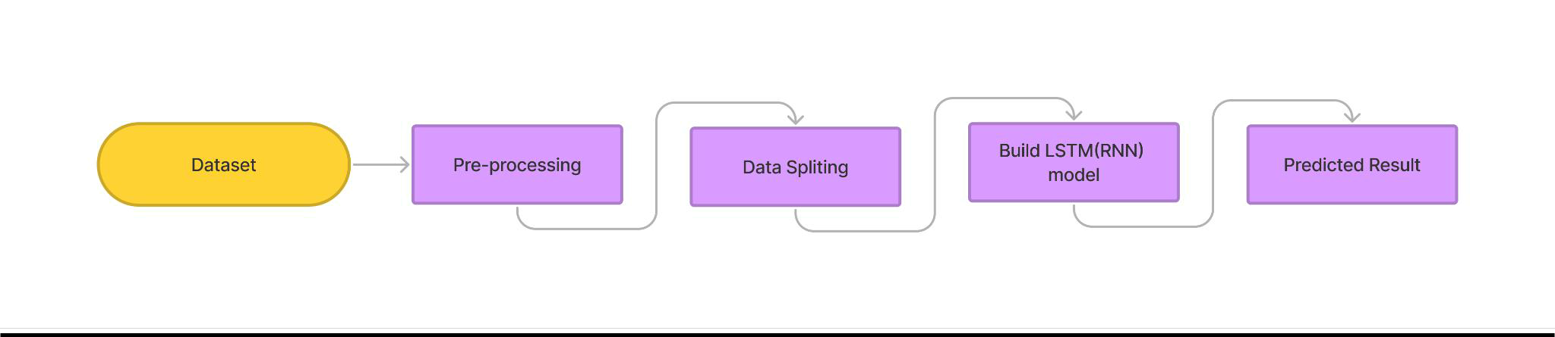

The system presented here composes of five modules:-

- Input as Dataset

- Pre-processing

- Data Splitting

- Build & Model train LSTM model

- Output as Predicted Result

Attribute such as: price of open, high, low, close, adjusted close price taken from huge dataset

are fed as input to the models for training to pre-process the data techniques like normalization

& one hot encoding is applied on the dataset. After this data is divided in two sets namely training

- testing which are ratios of 80:20 respectively. Then, this set is used to train a model using LSTM approaches: LST and thus modules are evaluated using Root Mean Square error.

14

CHAPTER 5

IMPLEMENTATION

5.1 DATA COLLECTION

We had to use the data sets of the publicly listed companies. There are several factors in the dataset, such as date, open, high, low, close, and trading rate. The Open price and Close price columns represent the original and final price. In reality, the stock exchange took place on that day. The low price, high price columns represent minimum and maximum share price for a given day. The very important thing here is to remember that the shops is not operating on weekends and public holidays therefore the data of those days are blank so it is going to affect the model in the accuracy since blank records affect any model negatively on wise of accuracy so The measurement of benefit or loss is basically being calculated by the selling price of a stock for the day; the closing price was therefore be known as the target variable. Data collection is a very basic module and the initial step towards the project. Here we are taking input data from Yahoo finance.
SOURCE CODE:
# -*- coding: utf-8 -*-
pip install yfinance
# Commented out IPython magic to ensure Python compatibility.
import pandas as pd
import numpy as np
from pandas_datareader import data as pdr
import yfinance as yf
import matplotlib.pyplot as plt
import seaborn as sns
sns.set_style('whitegrid')
plt.style.use("fivethirtyeight")
# %matplotlib inline
15

# For reading stock data from yahoo
from pandas_datareader.data import DataReader

# For time stamps
from datetime import datetime
import warnings
warnings.filterwarnings('ignore')
# The tech stocks we'll use for this analysis
tech_list = ['AAPL', 'GOOG', 'MSFT', 'AMZN']

# Set up End and Start times for data grab
end = datetime.now()
start = datetime(end.year - 1, end.month, end.day)

#For loop for grabing yahoo finance data and setting as a dataframe
for stock in tech_list:
# Set DataFrame as the Stock Ticker
globals()[stock] =yf.download(stock, start=start,end=end, progress=False)

company_list = [AAPL, GOOG, MSFT, AMZN]
company_name = ["APPLE", "GOOGLE", "AMAZON","MICROSOFT"]

for company, com_name in zip(company_list, company_name):
company["company_name"] = com_name

df = pd.concat(company_list, axis=0)
16
df.tail(10)

AAPL.describe()

# General info
AAPL.info()

# Let's see a historical view of the closing price

plt.figure(figsize=(15, 6))
plt.subplots_adjust(top=1.25, bottom=1.2)

for i, company in enumerate(company_list, 1):
plt.subplot(2, 2, i)
company['Adj Close'].plot()
plt.ylabel('Adj Close')
plt.xlabel(None)
plt.title(f"Closing Price of {tech_list[i - 1]}")

plt.tight_layout()

# Now let's plot the total volume of stock being traded each day
plt.figure(figsize=(15, 7))
plt.subplots_adjust(top=1.25, bottom=1.2)

for i, company in enumerate(company_list, 1):
plt.subplot(2, 2, i)
17
company['Volume'].plot()
plt.ylabel('Volume')
plt.xlabel(None)
plt.title(f"Sales Volume for {tech_list[i - 1]}")

plt.tight_layout()

ma_day = [10, 20, 50]

for ma in ma_day:
for company in company_list:
column_name = f"MA for {ma} days"
company[column_name] = company['Adj Close'].rolling(ma).mean()

fig, axes = plt.subplots(nrows=2, ncols=2)
fig.set_figheight(8)
fig.set_figwidth(15)

AAPL[['Adj Close', 'MA for 10 days', 'MA for 20 days', 'MA for 50 days']].plot(ax=axes[0,0])
axes[0,0].set_title('APPLE')

GOOG[['Adj Close', 'MA for 10 days', 'MA for 20 days', 'MA for 50 days']].plot(ax=axes[0,1])
axes[0,1].set_title('GOOGLE')

MSFT[['Adj Close', 'MA for 10 days', 'MA for 20 days', 'MA for 50 days']].plot(ax=axes[1,0])
axes[1,0].set_title('MICROSOFT')

AMZN[['Adj Close', 'MA for 10 days', 'MA for 20 days', 'MA for 50 days']].plot(ax=axes[1,1])
18
axes[1,1].set_title('AMAZON')

fig.tight_layout()

# We'll use pct_change to find the percent change for each day
for company in company_list:
company['Daily Return'] = company['Adj Close'].pct_change()

# Then we'll plot the daily return percentage
fig, axes = plt.subplots(nrows=2, ncols=2)
fig.set_figheight(8)
fig.set_figwidth(15)

AAPL['Daily Return'].plot(ax=axes[0,0], legend=True, linestyle='--', marker='o')
axes[0,0].set_title('APPLE')

GOOG['Daily Return'].plot(ax=axes[0,1], legend=True, linestyle='--', marker='o')
axes[0,1].set_title('GOOGLE')

MSFT['Daily Return'].plot(ax=axes[1,0], legend=True, linestyle='--', marker='o')
axes[1,0].set_title('MICROSOFT')

AMZN['Daily Return'].plot(ax=axes[1,1], legend=True, linestyle='--', marker='o')
axes[1,1].set_title('AMAZON')

fig.tight_layout()

# Note the use of dropna() here, otherwise the NaN values can't be read by seaborn
19
plt.figure(figsize=(12, 7))

for i, company in enumerate(company_list, 1):
plt.subplot(2, 2, i)
sns.distplot(company['Daily Return'].dropna(), bins=100, color='purple')
plt.ylabel('Daily Return')
plt.title(f'{company_name[i - 1]}')
# Could have also done:
#AAPL['Daily Return'].hist()
plt.tight_layout()

# Grab all the closing prices for the tech stock list into one DataFrame
closing_df = yf.download(tech_list, start, end,progress=False)['Adj Close']

closing_df.head()

# Make a new tech returns DataFrame
tech_rets = closing_df.pct_change()
tech_rets.head()

#Comparing Google to itself should show a perfectly linear relationship
import seaborn as sns
# Assuming 'GOOG' is the column in tech_rets DataFrame
sns.jointplot(x='GOOG', y='GOOG', data=tech_rets, kind='scatter', color='seagreen')

# We can simply call pairplot on our DataFrame for an automatic visual analysis
# of all the comparisons
20

sns.pairplot(tech_rets, kind='reg')

# Set up our figure by naming it returns_fig, call PairPLot on the DataFrame
return_fig = sns.PairGrid(tech_rets.dropna())

# Using map_upper we can specify what the upper triangle will look like.
return_fig.map_upper(plt.scatter, color='purple')

# We can also define the lower triangle in the figure, inclufing the plot type (kde)
# or the color map (BluePurple)
return_fig.map_lower(sns.kdeplot, cmap='cool_d')

# Finally we'll define the diagonal as a series of histogram plots of the daily return
return_fig.map_diag(plt.hist, bins=30)

# Set up our figure by naming it returns_fig, call PairPLot on the DataFrame
returns_fig = sns.PairGrid(closing_df)

# Using map_upper we can specify what the upper triangle will look like.
returns_fig.map_upper(plt.scatter,color='purple')

# We can also define the lower triangle in the figure, inclufing the plot type (kde) or the color map (BluePurple)
returns_fig.map_lower(sns.kdeplot,cmap='cool_d')

# Finally we'll define the diagonal as a series of histogram plots of the daily return
returns_fig.map_diag(plt.hist,bins=30)
21

# Let's go ahead and use sebron for a quick correlation plot for the daily returns
sns.heatmap(tech_rets.corr(), annot=True, cmap='summer')
sns.heatmap(closing_df.corr(), annot=True, cmap='summer')
# Let's start by defining a new DataFrame as a clenaed version of the oriignal tech_rets DataFrame
rets = tech_rets.dropna()
area = np.pi * 20
plt.figure(figsize=(10, 7))
plt.scatter(rets.mean(), rets.std(), s=area)
plt.xlabel('Expected return')
plt.ylabel('Risk')
for label, x, y in zip(rets.columns, rets.mean(), rets.std()):
plt.annotate(label, xy=(x, y), xytext=(50, 50), textcoords='offset points', ha='right', va='bottom',
arrowprops=dict(arrowstyle='-', color='blue', connectionstyle='arc3,rad=-0.3'))

# Get the stock quote
df = yf.download('AMZN', start='2012-01-01', end=datetime.now())
# Show teh data
df

plt.figure(figsize=(16,6))
plt.title('Close Price History')
plt.plot(df['Close'])
plt.xlabel('Date', fontsize=18)
plt.ylabel('Close Price USD ($)', fontsize=18)
plt.show()

# Create a new dataframe with only the 'Close column
22
data = df.filter(['Close'])
# Convert the dataframe to a numpy array
dataset = data.values
# Get the number of rows to train the model on
training_data_len = int(np.ceil( len(dataset) * .95 ))
training_data_len

# Scale the data
from sklearn.preprocessing import MinMaxScaler

scaler = MinMaxScaler(feature_range=(0,1))
scaled_data = scaler.fit_transform(dataset)

scaled_data

# Create the training data set
# Create the scaled training data set
train_data = scaled_data[0:int(training_data_len), :]
# Split the data into x_train and y_train data sets
x_train = []
y_train = []

for i in range(60, len(train_data)):
x_train.append(train_data[i-60:i, 0])
y_train.append(train_data[i, 0])
23
if i<= 61:
print(x_train)
print(y_train)
print()

# Convert the x_train and y_train to numpy arrays
x_train, y_train = np.array(x_train), np.array(y_train)

# Reshape the data
x_train = np.reshape(x_train, (x_train.shape[0], x_train.shape[1], 1))
# x_train.shape

from keras.models import Sequential
from keras.layers import Dense, LSTM

# Build the LSTM model
model = Sequential()
model.add(LSTM(128, return_sequences=True, input_shape= (x_train.shape[1], 1)))
model.add(LSTM(64, return_sequences=False))
model.add(Dense(25))
model.add(Dense(1))

# Compile the model
model.compile(optimizer='adam', loss='mean_squared_error')

# Train the model
model.fit(x_train, y_train, batch_size=1, epochs=1)
24
# Create the testing data set
# Create a new array containing scaled values from index 1543 to 2002
test_data = scaled_data[training_data_len - 60: , :]
# Create the data sets x_test and y_test
x_test = []
y_test = dataset[training_data_len:, :]
for i in range(60, len(test_data)):
x_test.append(test_data[i-60:i, 0])

# Convert the data to a numpy array
x_test = np.array(x_test)

# Reshape the data
x_test = np.reshape(x_test, (x_test.shape[0], x_test.shape[1], 1 ))

# Get the models predicted price values
predictions = model.predict(x_test)
predictions = scaler.inverse_transform(predictions)

# Get the root mean squared error (RMSE)
rmse = np.sqrt(np.mean(((predictions - y_test) ** 2)))
rmse

# Plot the data
train = data[:training_data_len]
valid = data[training_data_len:]
valid['Predictions'] = predictions
# Visualize the data
25
plt.figure(figsize=(16,6))
plt.title('Model')
plt.xlabel('Date', fontsize=18)
plt.ylabel('Close Price USD ($)', fontsize=18)
plt.plot(train['Close'])
plt.plot(valid[['Close', 'Predictions']])
plt.legend(['Train', 'Val', 'Predictions'], loc='lower right')
plt.show()

# ... (Previous code remains unchanged)

# Create the testing data set
test_data = scaled_data[training_data_len - 60:, :]
x_test, y_test = [], dataset[training_data_len:, :]
# Initialize x_test with the last 60 days of the existing data
x_test = [test_data[-60:]]
# Predict future values
predictions = []
for i in range(future_days):
pred = model.predict(np.reshape(x_test[-1], (1, 60, 1)))
predictions.append(pred[0, 0])
x_test.append(np.concatenate((x_test[-1][1:], pred[0, 0].reshape(1, -1))))
# Invert the scaling
predictions = np.array(predictions).reshape(-1, 1)
predictions = scaler.inverse_transform(predictions)
26
# Create a DataFrame for the next 30 days' predictions
prediction_dates = pd.date_range(df.index[-1] + pd.DateOffset(1), periods=future_days)
prediction_df = pd.DataFrame({'Date': prediction_dates, 'Predicted Close Price': predictions.flatten()})
# Display the table
prediction_df
valid.head()

27

CHAPTER 6

RESULTS
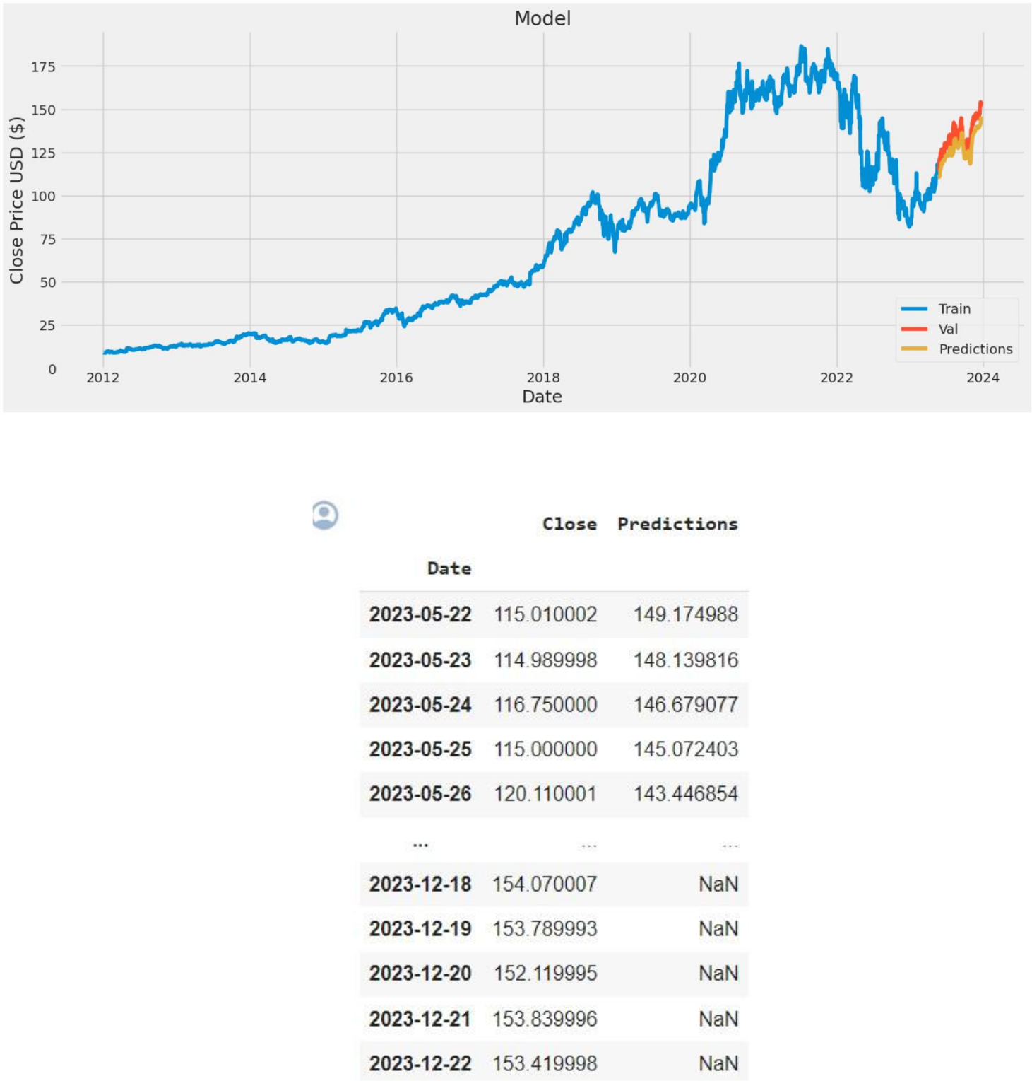

28

CHAPTER 7

CONCLUSION

CONCLUSION

In this project, we are predicting the closing stock price of any given organization. We developed a web application for predicting close stock prices using LMS and LSTM algorithms for prediction. We have applied datasets belonging to GOOG, TESLA, MSFT, AAPL and NETFLIX Stocks and achieved above 95% accuracy for these datasets.The changes in the stock market do not always be in a regular pattern or not always follow the continuous cycle. Based on the companies and sectors, the existence of the trends and the period of their existence will differ. The analysis of this type of cycles and trends can offer a more profit to the investors. In future work, we add more stock market data and compare more models to improve accuracy of predicted stock price.

FUTURE ENHANCEMENT

Future scope of this project will involve adding more parameters and factors like the financial ratios, multiple instances, etc. The more the parameters are taken into account the more will be the accuracy. The algorithms can also be applied for analyzing the contents of public comments and thus determine patterns/relationships between the customer and the corporate employee. The use of traditional algorithms and data mining techniques can also help predict the corporation’s performance structure as a whole.

29

REFERENCES

- Ashish Sharma , Dinesh Bhuriya , Upendra Singh. "Survey of Stock Market Prediction Using Machine Learning Approach", ICECA 2017.

- Loke. K. S. “Impact Of Financial-Ratios and Technical-Analysis on Stock-Price-Prediction Using Random Forests”, IEEE, 2017 .

- Xi Zhang1, Siyu Qu1, Jieyun Huang1, Binxing Fang1, Philip Yu2, “Stock Market Prediction via Multi-Source Multiple Instance Learning.” IEEE 2018.

- Leung, Carson Kai Sang, Richard Kyle-MacKinnon, Yang-Wang. “A machine learning approach for stock price prediction.” Proceedings of the 18th International Database Engineering & Applications Symposium. ACM , 2014 .

- VivekKanad , BhausahebDevikar , Sayali Phadtare , Pranali Mande , ShubhangiSonone “Stock Market Prediction: Using Historical Data Analysis”, IJARCSSE-2017.

- SachinSampatPatil, Prof. Kailash Patidar, Asst. Prof. Megha Jain, “A Survey on Stock Market Prediction Using SVM'', IJCTET-2016 .

- S. Hochreiter & J. Schmidhuber, "Long short-term memory", Neural computation, vol. 9, no. 8, pp. 1735-1780, 1997 .

- J. Chen and N. S. Chaudhari , "Segmented-memory recurrent neural networks," IEEE transactions on neural networks, vol. 20, no. 8, pp. 1267-1280, 2009.

30

